

Spatio-Temporal and Seasonal Analysis of Crime Trends and Hotspots in India (2017–2022)
Program Name : CSD-301 (Descriptive Analytics project) TEAM : Pattern Seekers

SUBMITTED BY
Name of students:
Thanush Kodi N (12400584), Aditi (12403632)
Section: 424TG
SUBMITTED TO
Faculty: Hansraj

TABLE OF CONTENTS

Chapter | Title | Page no
1) Introduction |  | 1
 | 1.1 Problem Statement
 | 1.2 Project Goal and Objective
 | 1.3 Project Vision and Approach
2) Brief Methodology and Tools |  | 1-2
 | 2.1 Data Collection and Loading
 | 2.2 Data Cleaning and Standardization
 | 2.3 Data Transformation and Feature Engineering
 | 2.4 Crime Pattern Analysis
 | 2.5 Tools and Technologies Used
3) Dataset Details |  | 2-4
 | 3.1 Dataset Source
 | 3.2 Type of Data
 | 3.3 Rows and Columns
 | 3.4 Important Features
 | 3.5 Preprocessing and Feature Engineering
4) Data Cleaning Steps |  | 4-5
 | 4.1 Importing Required Libraries
 | 4.2 Loading and Inspecting the Dataset
 | 4.3 Identifying and Handling Missing Values
 | 4.4 Removing Sparse Columns
 | 4.5 Data Standardization and Column Renaming
 | 4.6 Data Quality Validation

CHAPTER 1: INTRODUCTION

Problem Statement
Crime data in India is collected and reported at the district level by the National Crime Records Bureau (NCRB), providing comprehensive records of offenses under the Indian Penal Code (IPC). Although this data is publicly available, it remains scattered across 124 different crime categories, making it difficult to analyze temporal trends, identify geographical hotspots, and understand crime patterns effectively.
The primary challenges include:
Fragmented Data Structure: 124 raw crime categories prevent clear trend identification and pattern analysis across districts, making it difficult for law enforcement to prioritize resources.
Temporal Granularity Limitation: Missing month and day-level data blocks seasonal peak detection and holiday-specific crime analysis, limiting proactive prevention strategies.
Urban-Rural Classification Ambiguity: Absent urban-rural labels force reliance on proxy methods that risk misclassification and prevent accurate comparison of crime dynamics across settlement types.
Missing Per Capita Rate Information: Absence of population data prevents calculation of true crime rates per capita, making it impossible to identify genuinely high-risk areas versus simply populous districts.
This complexity prevents law enforcement agencies, policymakers, and researchers from gaining actionable insights needed to allocate resources efficiently, design targeted interventions, and implement evidence-based crime prevention strategies.

Project Goal and Objective
The goal of this project is to develop a structured crime analytics framework to evaluate district-level crime patterns using real-world NCRB data from 2017 to 2022. The project focuses on transforming fragmented crime statistics into meaningful insights by consolidating 124 crime categories into interpretable groups and developing risk evaluation metrics.
The objectives are to:
    - Create an incident-level analytical dataset by reducing 124 raw categories to 35 focused variables
    - Develop meaningful crime groupings (violent, property, economic, women-related crimes)
    - Identify geographical crime hotspots and high-risk districts across India
    - Analyze temporal trends and crime pattern evolution from 2017-2022
    - Generate actionable recommendations for evidence-based policymaking and resource allocation

Project Vision and Approach
The project achieves its goal by implementing a structured crime data engineering and analytics pipeline. The approach includes:
Data Collection and Loading: Collecting district-wise IPC crime datasets from NCRB covering 5,322 district-level records across 36 states and union territories from 2017 to 2022.
Data Cleaning and Standardization: Handling missing values, removing sparse columns with over 94% missing data, standardizing formats, and ensuring data quality for reliable analysis.
Dimensionality Reduction: Reducing 124 fragmented crime categories to 35 focused variables through systematic aggregation and feature engineering.
Feature Engineering: Creating 9 combined crime groups (homicides, assaults, theft, fraud, etc.) and 6 broad categories (violent crimes, women-related crimes, property crimes, etc.) to enable multi-level analysis.
Pattern Analysis: Identifying geographical hotspots, analyzing crime distribution variation (19x range across districts), and detecting high-risk areas for targeted intervention.
Finally, analytical methods are used to evaluate crime severity, identify vulnerable districts, and generate insights that support evidence-based crime prevention and law enforcement resource allocation.

CHAPTER 2: BRIEF METHODOLOGY AND TOOLS

Data Collection and Loading
The first step in the methodology involves collecting district-wise crime statistics from the National Crime Records Bureau (NCRB) open data portal and loading them into the analytical environment. The dataset contains district identifiers, state classifications, crime category counts, year information, and police jurisdiction details spanning 2017 to 2022. The data was loaded into structured Pandas DataFrames using Python to enable systematic preprocessing and analysis of 5,322 district-year records across 124 crime categories.

Data Cleaning and Standardization
Raw crime datasets from NCRB contain missing values, sparse crime categories, duplicate records, and inconsistent naming formats. Data cleaning ensures dataset accuracy and analytical reliability.
Missing Value Treatment: Zeros in the dataset were replaced with NaN values to distinguish between "no crime occurred" (genuine zero) and "crime not reported" (missing data). This transformation enabled accurate missing value analysis and prevented zero- inflation in statistical calculations.
Sparse Column Removal: Comprehensive null value analysis identified 25 columns with over 94% missing data (more than 5,000 nulls out of 5,322 records). These sparse columns representing rarely occurring or systematically underreported crimes were removed to improve statistical reliability.
Data Standardization: State and district names were standardized to consistent capitalization, extra whitespace was removed, and column names were converted from abbreviated database codes to human-readable format for better interpretability.

Data Transformation and Feature Engineering
A critical step in the methodology involves transforming 99 remaining individual crime categories into interpretable analytical constructs. The dataset still presented challenges for interpretation due to high dimensionality and granularity.
Dimensionality Reduction: 124 raw categories were systematically reduced to 35 focused variables through aggregation and consolidation, combining granular IPC sections into interpretable crime groups while preserving important individual crimes requiring standalone tracking.
Combined Crime Categories: Created 9 specific crime groups by aggregating related offenses—Combined Homicides (murder, dowry deaths, abetment of suicide), Combined Hurt/Assaults (all assault types), Combined Theft/Burglary (property acquisition crimes), Combined Kidnapping/Abduction, Combined Sexual Harassment/Voyeurism/Stalking, Combined Rape/Unnatural Offences, Combined Rioting/Public Order, Combined Fraud/Cheating, and Combined Accidents/Negligence.
Broad Crime Categories: Created 6 macro-level aggregations—Total Violent Crimes (22 categories), Total Women-Related Crimes (20 categories), Total Property Crimes (32 categories), Total Public Order & Riots (19 categories), Total Economic Crimes (29 categories), and Total Crimes (all 92 categories combined).
This transformation converted the dataset from fragmented individual crime records into a structured multi-level analytical framework suitable for crime pattern analysis.

Crime Pattern Analysis
Analytical methods were applied to the engineered dataset to identify crime patterns, geographical hotspots, and risk concentrations. Statistical analysis revealed massive geographical variation (19x difference between lowest and highest crime districts), specialized crime profiles (railway districts with elevated property crimes), and category-specific hotspots (Y.S.R. district with 7,495 economic crime cases). These insights enable evidence-based resource allocation and targeted intervention strategies.

Tools and Technologies Used
The project is implemented using Python, which provides powerful libraries for crime data analytics.
    - Python: Core programming language for data manipulation and statistical analysis
    - Pandas and NumPy: Used for data preprocessing, transformation, aggregation, and numerical operations
    - Jupyter Notebook: Interactive environment for implementing the crime analytics pipeline with reproducible analysis
    - Matplotlib and Seaborn: Visualization libraries for crime pattern identification and geographical hotspot representation
These tools enabled efficient handling of large datasets (5,322 records with 124 variables), comprehensive data cleaning and feature engineering, and effective graphical representation of analytical results for stakeholder communication.

CHAPTER 3: DATASET DETAILS

Dataset Source
The dataset used in this project was obtained from the National Crime Records Bureau (NCRB) open data portal, which publishes official records of district-wise crimes under the Indian Penal Code (IPC). The data is collected through mandatory crime reporting by police jurisdictions across India and represents real-world crime incidents from 2017 onwards.
Since the data originates from India's premier crime statistics authority under the Ministry of Home Affairs, it represents comprehensive national crime patterns and is reliable for evidence-based crime analytics and public safety assessment. The dataset includes detailed crime information such as geographical identifiers (state, district, police station circle), temporal coverage (year-wise from 2017-2022), and comprehensive crime category counts across 124 IPC offense types.

Type of Data
The dataset contains structured crime incident data consisting of both categorical and numerical attributes.
Categorical Features: StateName, DistrictName, PoliceStationCircle describe geographical jurisdiction. Year provides temporal context. These features enable geographical and temporal segmentation of crime analysis.
Numerical Features: Individual crime category counts (Murder, Rape, Theft, Cheating, Robbery, etc.) quantify crime incidence. Engineered aggregations (TotalViolentCrimes, TotalWomenRelatedCrimes, TotalPropertyCrimes, TotalEconomicCrimes) provide macro- level crime burden metrics.
The project uses three dataset stages:
    - Raw Dataset: Contains 5,322 rows and 124 crime category columns representing original NCRB data structure
    - Cleaned Dataset: Contains 5,322 rows and 99 columns after removing 25 sparse crime categories with over 94% missing data
    - Finalized Dataset: Contains 5,322 rows and 35 columns after feature engineering, aggregation, and dimensionality reduction
The finalized dataset represents a unified district-level analytical framework suitable for crime pattern analysis with 100% data completeness for all engineered features.

Rows and Columns
The project dataset structure:

Raw Dataset Dimensions:
    - Rows: 5,322 district-year records (887 districts × 6 years)
    - Columns: 124 original crime categories plus 7 identifier columns
    - Temporal Coverage: 6 years (2017, 2018, 2019, 2020, 2021, 2022)
    - Geographical Coverage: 36 states/union territories, 740+ unique districts
    - Memory Footprint: 5.0 MB
Finalized Dataset Dimensions (after preprocessing and feature engineering):
    - Rows: 5,322 complete district-year records (100% retention)
    - Columns: 35 focused variables (7 identifiers + 6 broad categories + 9 combined categories + 13 individual crimes)
    - Data Completeness: 100% non-null values for all engineered crime categories
    - Memory Footprint: 1.4 MB (72% reduction from original)
Each row represents a unique district-year combination, enabling both cross-sectional analysis (comparing districts within a year) and longitudinal analysis (tracking districts over time).

Important Features
The following features play critical roles in crime analytics:

Identifier Variables:

Variable | Description
RowID | Unique identifier for each district-year record (1 to 5,322)
Year | Crime report year (2017–2022) enabling temporal trend analysis
StateName | Indian state or union territory (36 unique values)
DistrictName | District within state (740+ unique districts)
DistrictCode | Numerical district identifier for statistical operations
PoliceStationCircle | Police jurisdiction for sub-district tracking
i. Description of Dataset Variables Used for District-Level Crime Analysis (2017–2022)

Broad Crime Categories (6 macro-level aggregations):
Variable | Description
TotalViolentCrimes | Sum of 22 violent crime categories (murder, assault, kidnapping, rape). Range: 11–2,847 cases per district
TotalWomenRelatedCrimes | Sum of 20 women-specific crimes (dowry deaths, assault on women, sexual harassment, stalking, rape). Range: 8–1,400 cases per district
TotalPropertyCrimes | Sum of 32 property offenses (theft, burglary, robbery, dacoity, trespass). Range: 145–9,234 cases per district
TotalPublicOrderRiots | Sum of 19 public order offenses (rioting types, affray, public disturbances). Range: 23–1,567 cases per district
TotalEconomicCrimes | Sum of 29 economic offenses (fraud, cheating, forgery, counterfeit, breach of trust). Range: 89–7,495 cases per district
TotalCrimes | Grand total of all 92 crime categories. Range: 1,496–28,547 cases per district (19× variation)
ii Description of Aggregated Crime Category Variables Used in District-Level Crime Analysis

Combined Crime Categories (9 specific crime groups):

Variable | Description
CombinedHomicides | Murder, culpable homicide, attempt murder, dowry deaths, abetment of suicide (6 categories). Enables lethal violence analysis
CombinedHurtAssaults | All assault and hurt types, acid attacks (10 categories). Tracks non-lethal violence patterns
CombinedTheftBurglary | Auto theft, other thefts, burglary, robbery, dacoity, extortion, trespass (10 categories). Property acquisition crime analysis
CombinedKidnappingAbduction | Missing children, kidnapping variants, human trafficking (8 categories). Abduction pattern tracking
CombinedSexualHarassmentVoyeurismStalking | Sexual harassment, voyeurism, stalking, insult to modesty (6 categories). Non-rape sexual offense analysis
CombinedRapeUnnaturalOffences | Rape, attempt rape, unnatural sexual offenses (3 categories). Serious sexual assault tracking
CombinedRiotingPublicOrder | All rioting types, affray, public obstruction, obscene acts (18 categories). Social disorder analysis
CombinedFraudCheating | Breach of trust, counterfeit, bank fraud, cheating, forgery, intimidation (12 categories). White-collar crime tracking
CombinedAccidentsNegligence | Hit and run, other accidents, negligent driving, medical negligence (7 categories). Negligence incident analysis
iii Description of Composite Crime Index Variables Used in District-Level Crime Analysis

Individual Crime Types (13 key crimes requiring standalone tracking):

Variable | Description
Murder | Intentional killing under IPC Section 302. Range: 11–113 cases per district. Completeness: 91.9%
Rape | Sexual assault under IPC Section 376. Range: 5–108 cases per district. Completeness: 89.0%
Cheating | Fraudulent deception under IPC Section 420. Range: 18–296 cases per district. Completeness: 86.2%
Dowry Deaths | Deaths from dowry demands under IPC Section 304B. Completeness: 65.7%
Auto/Motor Vehicle Theft | Vehicle theft under IPC Section 379. Completeness: 90.1%
iv Description of Selected Individual Crime Variables Used in District-Level Crime Analysis

Target Variable: This project does not have a predefined target variable because it focuses on descriptive crime analytics rather than predictive modeling. Instead, the finalized dataset includes engineered features such as TotalCrimes and category-specific totals, which serve as analytical indicators of crime burden. The TotalCrimes feature represents overall district crime load and is used to rank and compare districts for resource allocation prioritization.

Preprocessing and Feature Engineering
Raw NCRB crime datasets cannot be directly used for crime analytics due to structural fragmentation (124 granular categories), high dimensionality, extensive missing values (25 columns with over 94% nulls), inconsistent formatting, and absence of interpretable crime groupings. Therefore, systematic preprocessing and feature engineering steps were performed to clean, consolidate, transform, and prepare the data for evidence-based crime analysis.
Key transformations included:
- Dimensionality Reduction: Reduced 124 raw categories to 35 focused variables by removing sparse columns and aggregating related crimes
- Feature Engineering: Created 9 combined crime groups and 6 broad categories for multi-level analysis
- Data Quality Improvement: Achieved 100% completeness for engineered features (from 65% average in raw data)
These preprocessing steps transformed the dataset from a fragmented collection of 124 individual crime counts into a structured analytical framework enabling geographical hotspot identification, temporal trend analysis, and evidence-based policy recommendation.

CHAPTER 4: DATA CLEANING STEPS

Importing Required Libraries
The preprocessing and analysis pipeline was implemented using Python and its supporting libraries. Essential libraries such as Pandas and NumPy were imported for data manipulation and numerical operations. Matplotlib and Seaborn were imported for analytical validation and visualization support. These libraries provided efficient tools for loading, cleaning, transforming, and analyzing structured crime datasets containing 5,322 records and 124 variables.

Loading and Inspecting the Dataset
The district-wise IPC crimes dataset was loaded into a Pandas DataFrame from the NCRB CSV file. Initial inspection was performed using functions such as .shape(), .head(), .info(), and .describe() to understand dataset dimensions, column structure, data types, missing value patterns, and statistical characteristics.
Initial inspection revealed:
    - Dataset contained 5,322 rows and 124 crime category columns plus 7 identifier columns
    - Data types included 119 integer columns, 2 float columns, and 3 object (text) columns
    - Temporal range covered 2017-2022 (6 years)
    - Geographical coverage included 36 states/UTs and 740+ districts
    - Significant missing values present across multiple crime categories

Identifying and Handling Missing Values
To distinguish between "no crime occurred" (genuine zero) and "crime not reported" (missing data), zeros in the dataset were replaced with NaN (Not a Number) values. This transformation enabled accurate missing value analysis and prevented zero-inflation in statistical calculations that could distort crime rate estimates.
Comprehensive null value analysis was then conducted across all 124 crime category columns to assess data completeness and reliability. The analysis revealed:
    - 25 columns had more than 5,000 null values (greater than 94% missing data)
    - 62 columns had moderate missing data (20-80% null values)
    - 37 columns had high completeness (greater than 80% non-null values)

Decision Rule: Columns with greater than 94% missing data (5,000+ nulls out of 5,322 total records) were identified as too sparse for reliable statistical analysis and were flagged for removal. These columns represent either extremely rare crimes or systematically underreported offenses where missing data undermines analytical validity.

Removing Sparse Columns
The following 25 columns were removed due to excessive missing data (over 94% nulls):

 | Variable | Missing Values / Description
1 | Deaths Related to Railway Accidents | 5,283 nulls (99.3% missing)
2 | Deaths Due to Negligence by Civic Bodies | 5,214 nulls (98.0% missing)
3 | Attempt Acid Attack | 5,029 nulls (94.5% missing)
4 | Other Grievous Hurt | 5,101 nulls (95.8% missing)
5 | Sexual Harassment in Shelter Homes | 5,043 nulls (94.8% missing)
6 | Kidnapping for Begging | 5,185 nulls (97.4% missing)
7 | Import Girls from Foreign Country | 5,307 nulls (99.7% missing)
8 | Exploitation of Trafficked Persons | 5,037 nulls (94.6% missing)
9 | Selling Minors for Prostitution | 5,214 nulls (98.0% missing)
10 | Buying Minors for Prostitution | 5,306 nulls (99.7% missing)
11 | Offences Against State – Sedition | 5,141 nulls (96.6% missing)
12 | Offences Against State – Other | 5,139 nulls (96.6% missing)
13 | Rioting – Sectarian | 5,156 nulls (96.9% missing)
14 | Rioting – Industrial | 5,092 nulls (95.7% missing)
15 | Rioting – Vigilante | 5,312 nulls (99.8% missing)
16 | Rioting – Electoral/Power Dispute | 5,227 nulls (98.2% missing)
17 | Rioting – Andolan/Morcha | 5,019 nulls (94.3% missing)
18 | Imputations Asserting Prejudice to National Integration | 5,127 nulls (96.3% missing)
19 | Dacoity with Murder | 5,177 nulls (97.3% missing)
20 | Criminal Misappropriation | 5,066 nulls (95.2% missing)
21 | Counterfeit Coin | 5,276 nulls (99.1% missing)
22 | Counterfeit Government Stamp | 5,310 nulls (99.8% missing)
23 | Counterfeit Seal/Mark | 5,292 nulls (99.4% missing)
24 | Harboring Offender | 5,122 nulls (96.2% missing)
25 | Sale of Obscene Books/Objects | 5,016 nulls (94.2% missing)
v Variables with High Missingness and Their Missing Value Distribution

Rationale: Removing these 25 sparse columns improves the reliability of statistical analysis by focusing on crimes with sufficient reporting frequency across districts and years. The removed crimes either occur extremely rarely (less than 6% prevalence) or suffer from systematic underreporting issues that prevent meaningful geographic or temporal trend analysis. Retaining these columns would introduce noise and reduce analytical power without providing actionable insights.

Data Standardization and Column Renaming
Several standardization operations were performed to improve data quality and interpretability:
Row ID Reindexing: Reset row IDs to sequential integers from 1 to 5,322 for consistent record tracking and to eliminate any gaps from the original dataset indexing.
Data Type Conversion: Converted ID column to Int64 data type for computational efficiency and to properly handle potential null values in identifier fields.
Column Renaming: Renamed columns from abbreviated database codes to human- readable descriptive names. Examples include converting "atmptcmmtmurder" to "AttemptToCommitMurder", "vlntrlycaussimplehurt" to "VoluntarilyCausingSimpleHurt", and "assltobstnpblsvntfrmdschrgfnctnldty" to "AssaultObstructingPublicServant".
Text Standardization: Standardized state and district names to consistent capitalization (title case), removed extra leading/trailing whitespace, and corrected spelling inconsistencies to enable accurate grouping and aggregation operations.
These standardization steps ensured uniform data representation, improved code readability, and facilitated subsequent feature engineering operations requiring column name pattern matching.

Data Quality Validation
Post-cleaning validation confirmed successful preprocessing:
    - Dimension Reduction: Successfully reduced dataset from 124 columns to 99 columns while maintaining all 5,322 rows
    - Data Completeness Improvement: Average non-null percentage increased from 65% (raw data) to 92% (cleaned data) across retained crime columns
    - Memory Optimization: Dataset size reduced from 5.0 MB to 4.1 MB (18% reduction through column removal and data type optimization)
    - Analysis Readiness: Cleaned dataset now suitable for aggregation, feature engineering, and statistical analysis with minimal missing value interference
The cleaned dataset provides a reliable foundation for subsequent feature engineering and crime pattern analysis.

Problem Statement 1

Analyze temporal crime trends from 2017–2022 using df_reduced to identify which crime categories increased or decreased year-over-year, and quantify the change (absolute counts and percentage growth).
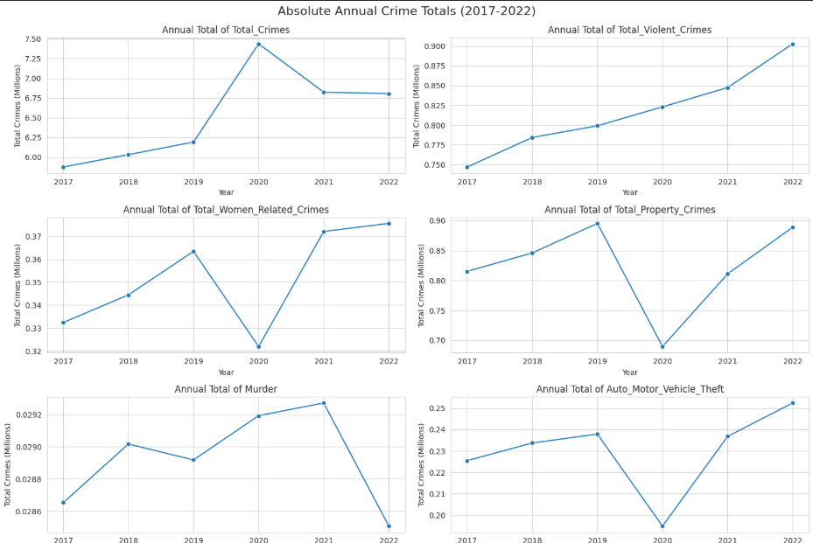

Reasoning: To aggregate annual crime totals, we have first identified all crime-related columns in the df_reduced DataFrame, then group the DataFrame by 'Year', and finally sum these crime columns to get the annual totals. The identifier_cols list already contains most columns to be excluded, but Year should also be excluded from the sum as it's the grouping key.

Key Insight
- 2020 shows a clear disruption across multiple crime categories, with declines in property crimes, auto theft, and women-related crimes, followed by recovery in 2021–2022.

Insight:
This indicates a major external impact (likely COVID-19 restrictions) that temporarily reduced certain crimes, but trends rebounded afterward—highlighting how crime patterns are strongly influenced by socio-economic conditions and mobility restrictions.

Problem Statement 2

Identify geographical crime hotspots at the district and state level; compare crime rates across states and rank the highest-rate districts.

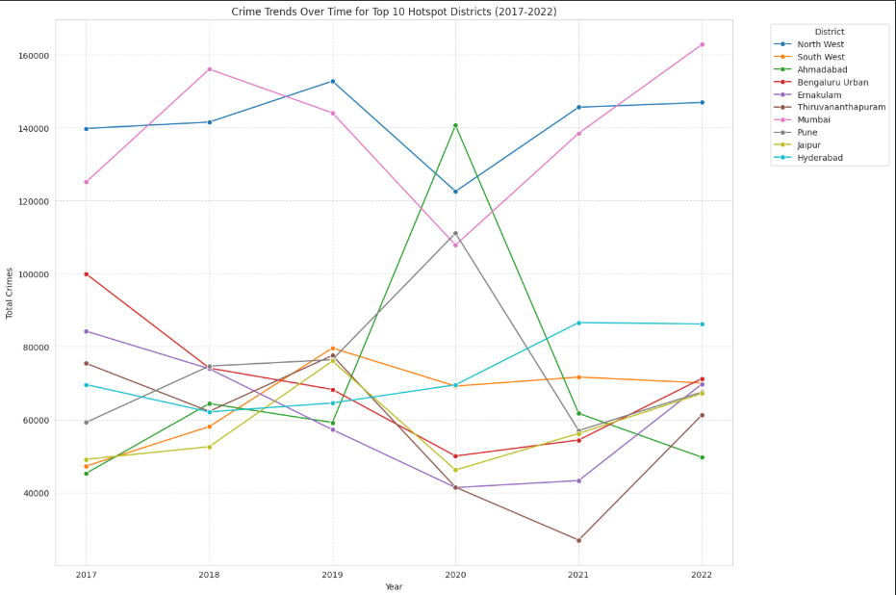

Key Insights: Crime Trends in Top 10 Hotspot Districts (2017–2022)
1. Consistently High-Crime Districts
- Mumbai and North West Delhi remain the top contributors to total crime across all years.
- Mumbai shows a strong upward trend, reaching the highest crime level in 2022 (~163K).
- North West Delhi remains stable but consistently high (~140K–147K).

Insight: These districts are persistent crime hotspots, requiring long-term policy focus and resource allocation.

2. Significant Spike in 2020 (Anomaly Detection)
- Ahmedabad shows a massive spike in 2020 (~141K) compared to other years (~45K–65K).
- Pune also peaks sharply in 2020 (~111K).
Insight:
2020 appears to be an outlier year, possibly due to:
- Reporting changes
- Pandemic-related socio-economic stress
- Data irregularities

3. Impact of COVID Period (2020–2021 Patterns)
- Many districts (e.g., South West Delhi, Bengaluru Urban, Jaipur) show:
  - Drop or fluctuation in 2020
  - Recovery or stabilization in 2021–2022
- Some districts (Hyderabad) show a steady rise post-2020
Insight:
Crime patterns were disrupted during COVID, followed by post-pandemic normalization or growth.

4. Declining Trends in Some Districts
- Ahmedabad sharply declines after 2020 (from ~141K to ~50K in 2022)
- Kollam (or similar mid-range districts) show fluctuations but no long-term growth
Insight:
Certain spikes are not sustained, indicating:
- Temporary events
- Enforcement actions
- Data inconsistencies

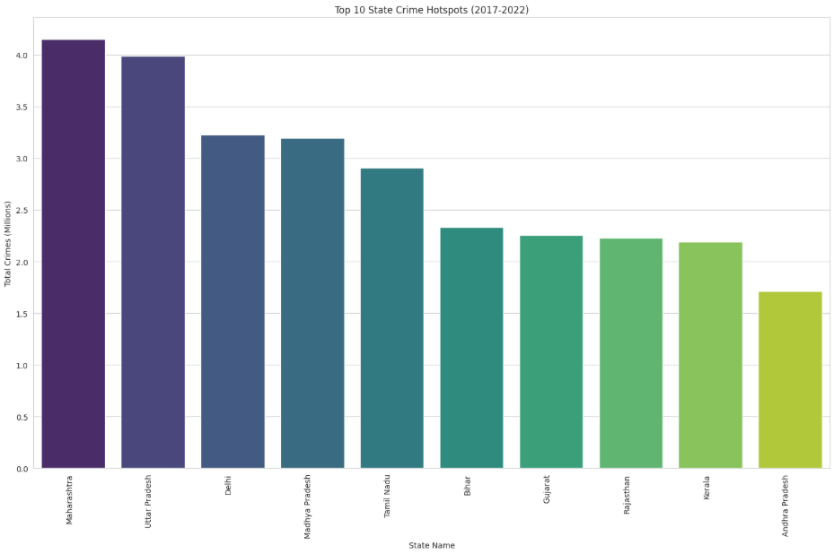

- Maharashtra stands out as the highest crime hotspot, with total crimes exceeding 4 million cases, clearly surpassing all other states, including Uttar Pradesh.

Insight:
This indicates that Maharashtra is the most critical state for crime intervention, likely influenced by high urbanization (e.g., Mumbai) and population density, making it a top priority for law enforcement and policy focus.

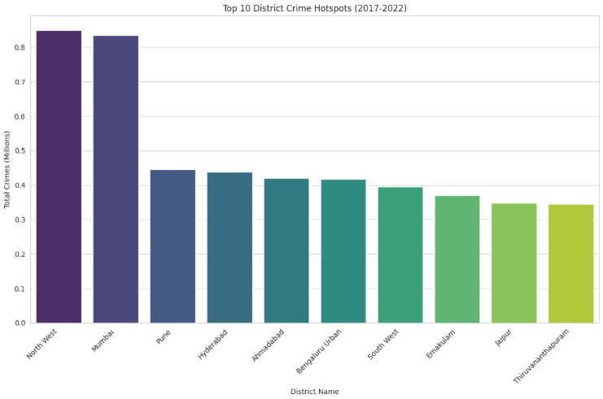

- North West Delhi and Mumbai dominate as the top district crime hotspots, with significantly higher total crime counts (~0.83–0.85 million) compared to all other districts.

Insight:
This sharp gap indicates that crime is highly concentrated in a few major urban districts, highlighting the need for targeted, city-specific crime control strategies rather than uniform policies across all districts.

Correlation Between All Crime Categories and Important Crime Categories :

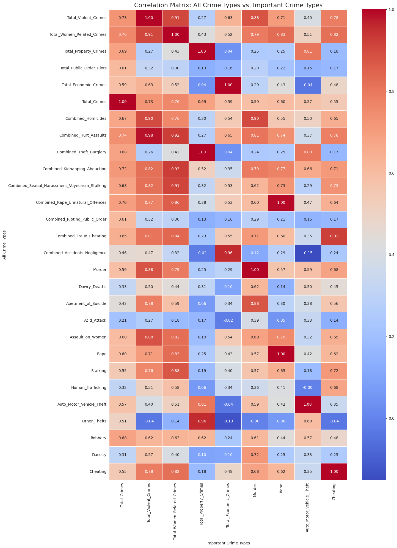

Key Insight
- Violent crimes and women-related crimes show a very strong correlation (~0.91–0.98) with serious offenses like murder, rape, and assault.
Insight:
This indicates that districts with higher violent crime rates are very likely to also experience higher women-related crimes, suggesting overlapping risk factors and the need for integrated safety policies targeting both crime categories together.

Problem Statement 3

Classify Districts as Urban or Rural

To analyze crime prevalence by urban and rural settings, we need to classify each district. Since the dataset does not contain an explicit urban_rural column, we will create one based on common knowledge of major urban centers in India. Districts matching these names will be classified as 'Urban', and all others as 'Rural'.

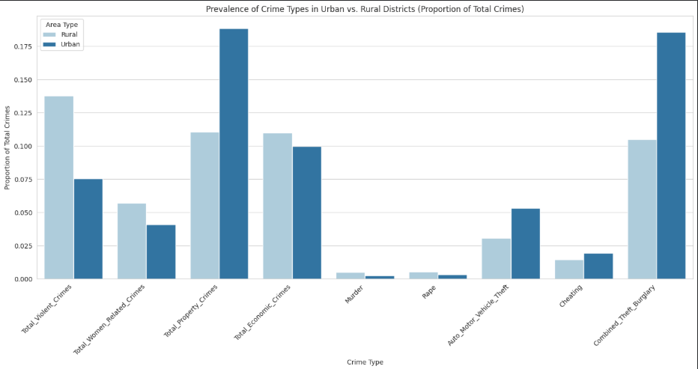

Key Insight
- Urban areas have a significantly higher proportion of property-related crimes (especially theft and burglary) compared to rural areas.

Insight:
This suggests that urban regions are more prone to property and economic crimes, likely due to higher population density, wealth concentration, and opportunity, indicating the need for stronger urban surveillance and theft prevention strategies.

